**Assignment 1:**

Create a row vector that has the elements: 1, 5, 4, 8, 6, tan(pi/3) and cos(pi/3).

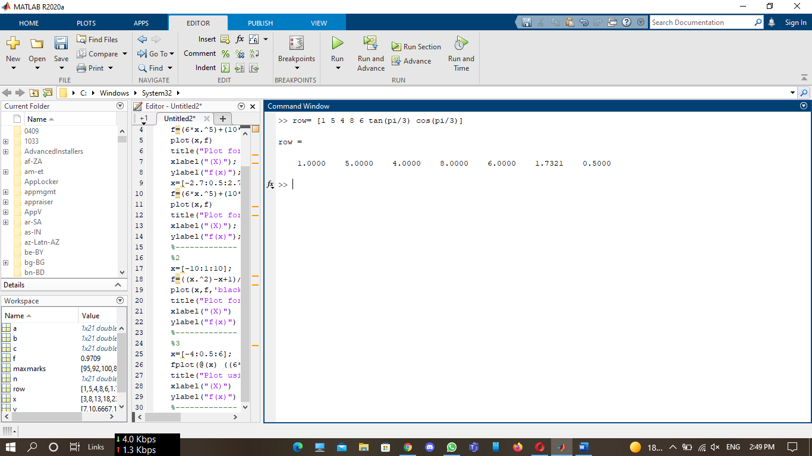

**Assignment 2:**

Creating a vector with constant spacing by specifying the first term, the spacing, and the last term

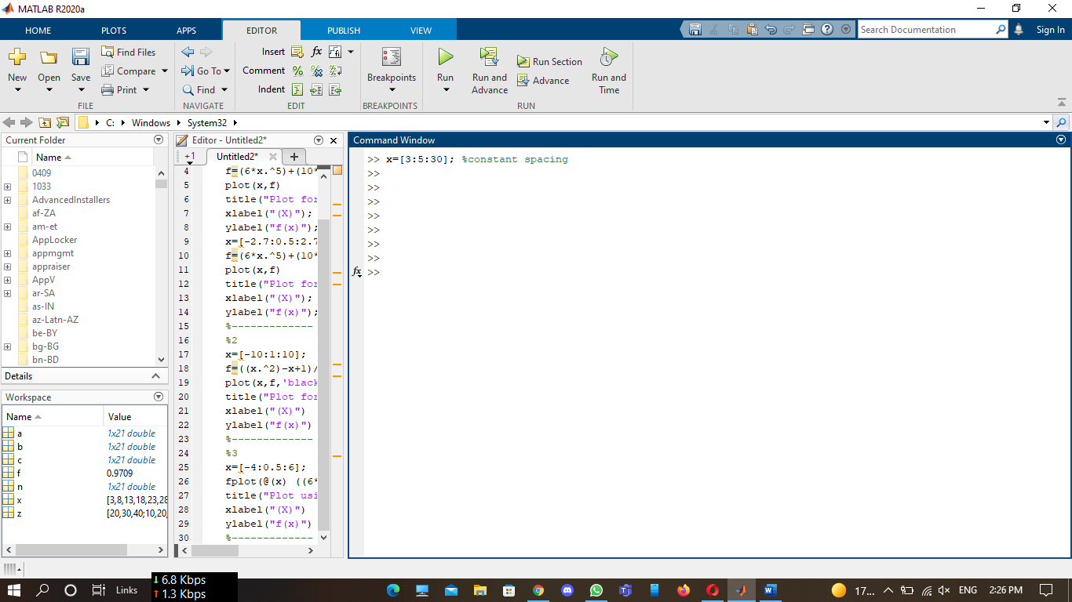

**Assignment 3:**

Create a row vector in which the first element is 100, the elements decrease with increments of -5 and the last element is 0.

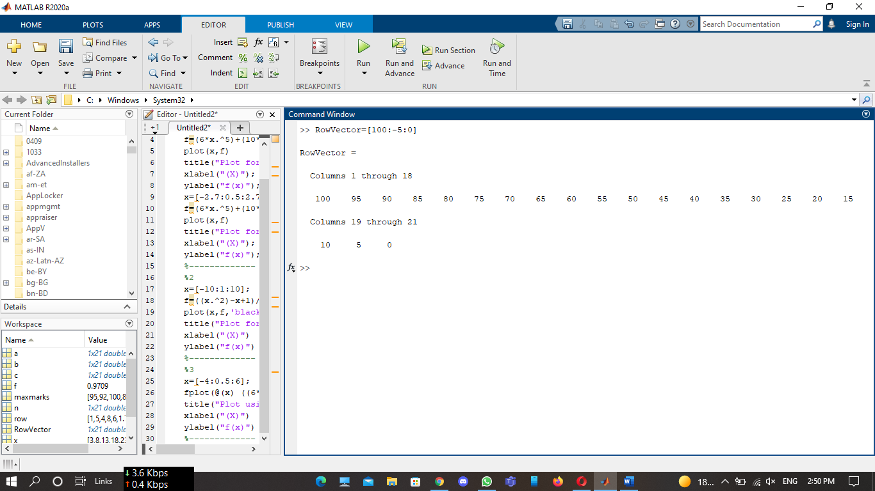

**Assignment 4:**

Create a row vector with 10 equally spaced elements in which the first element is 7 and the last element is 40.

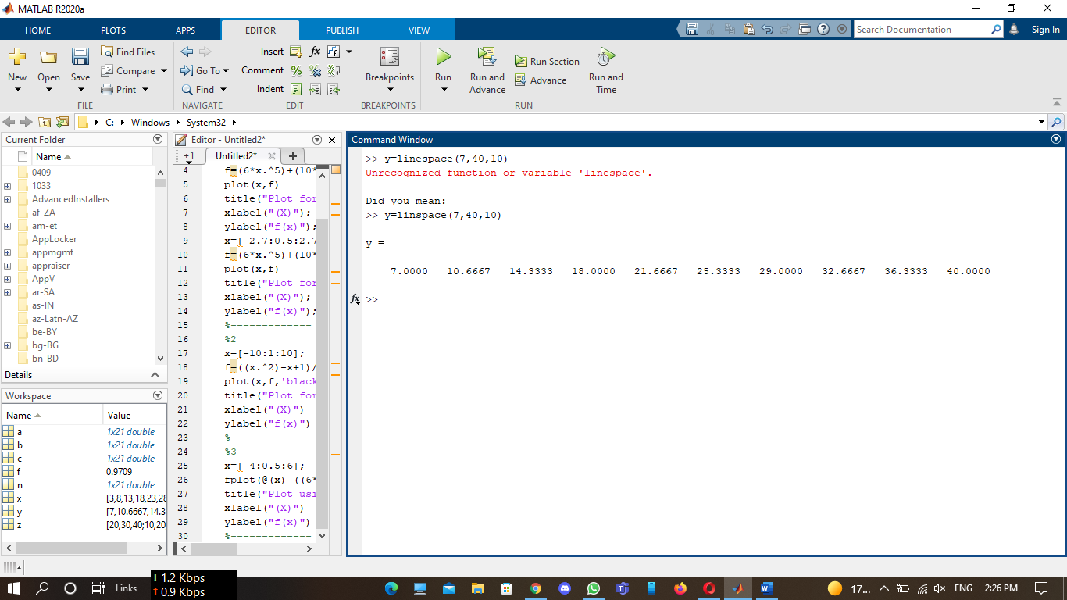

**Assignment 5:**

Create a column vector with 12 equally spaced elements in which the first element is -1 and the last element is -15.

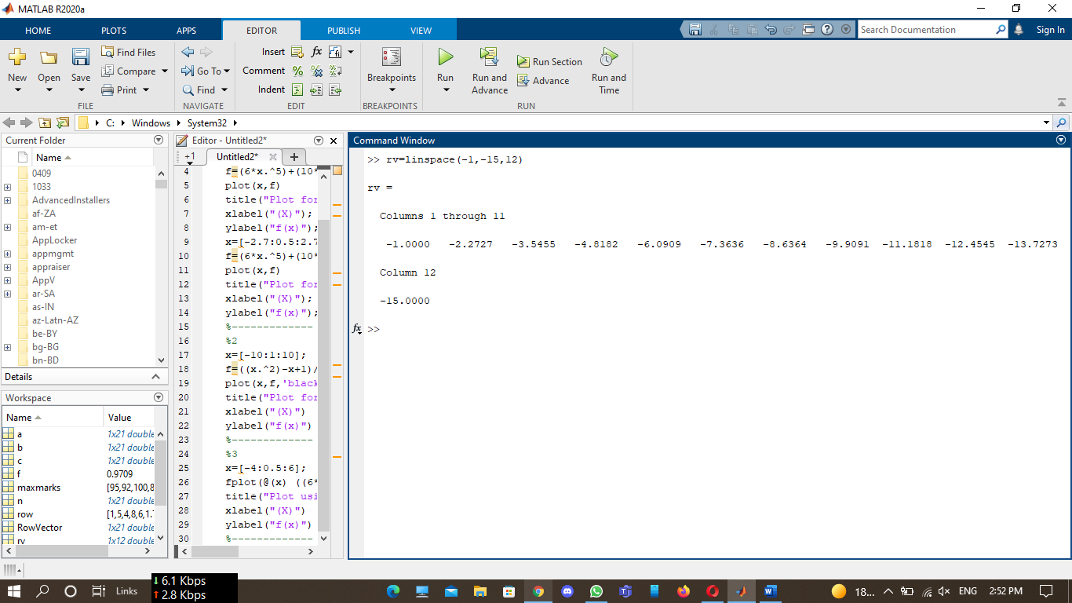

**Assignment 6:**

Create the matrix shown below by using the vector notation for creating vectors with constant linspace command when entering the rows.

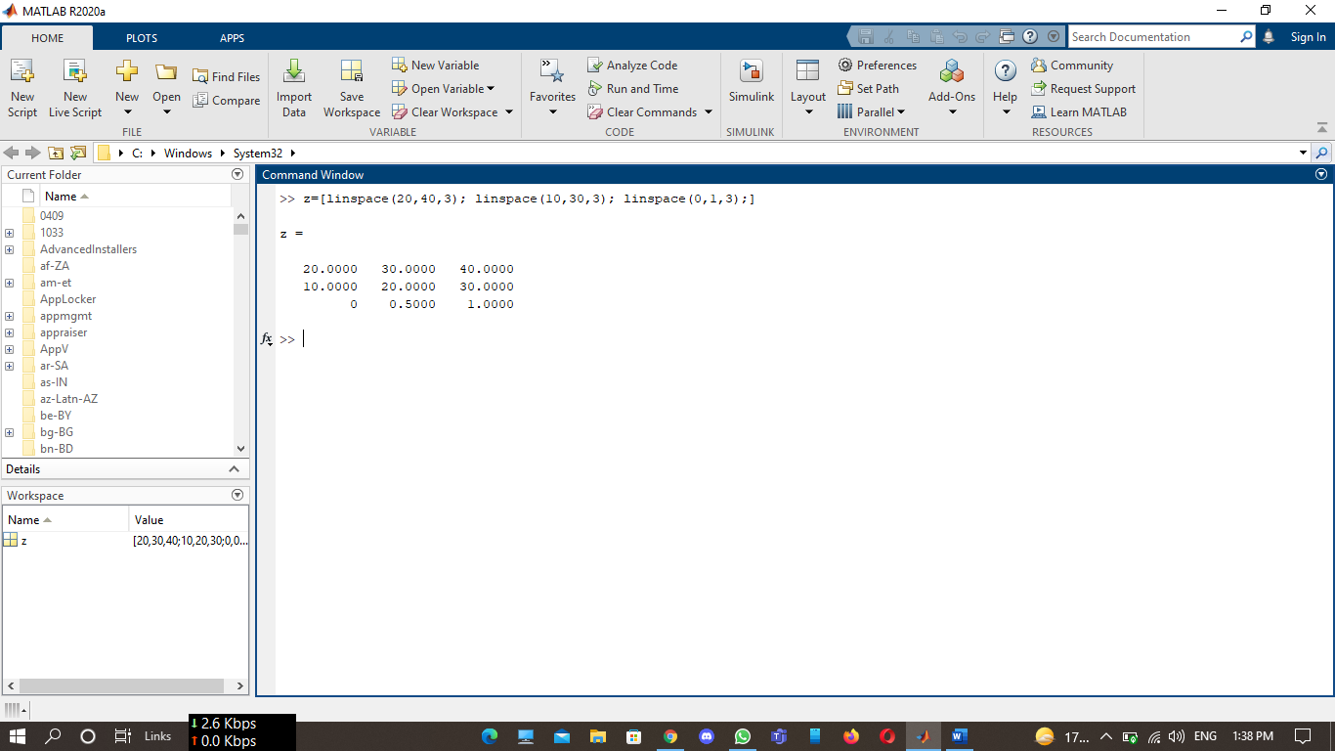

**Assignment 7:**

Create the following matrix *A:*

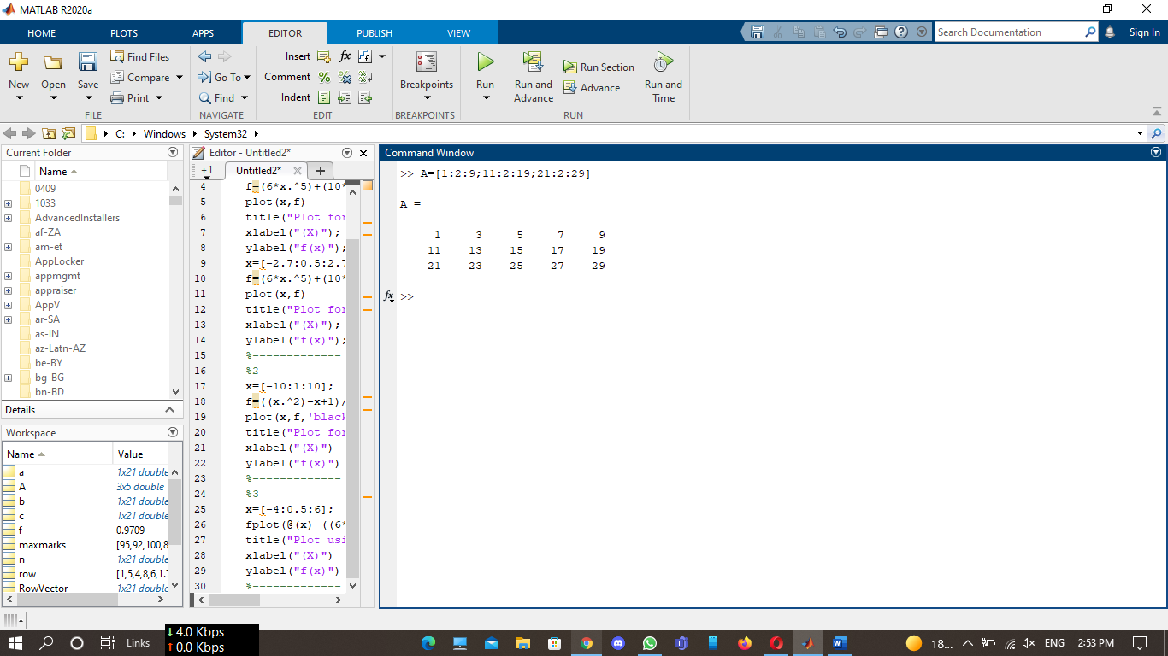

Use the matrix *A* to:

1. Create a five-element row vector named va that contains the elements of the second row of *A.*

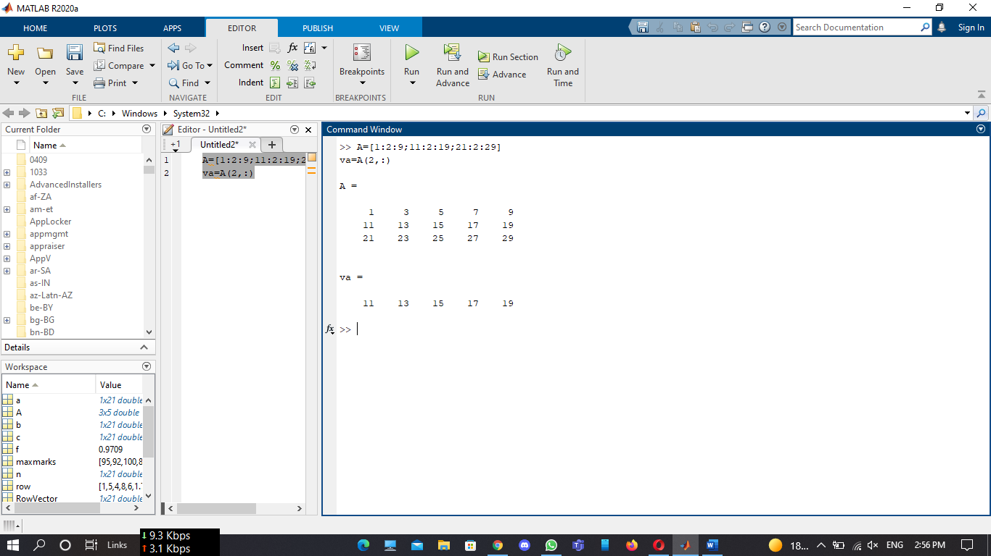

1. Create a three-element row vector named vb that contains the elements of the fourth column of A.

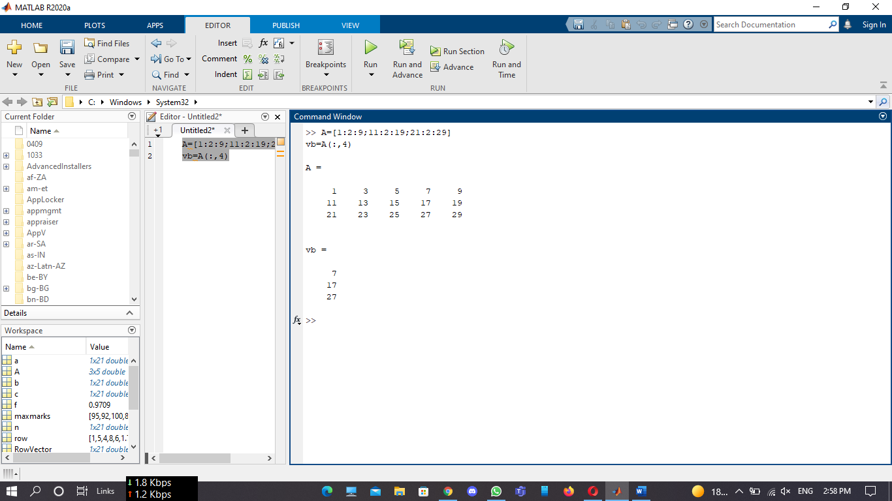

1. Create a ten-element row vector named vc that contains the elements of the first and second rows of *A.*

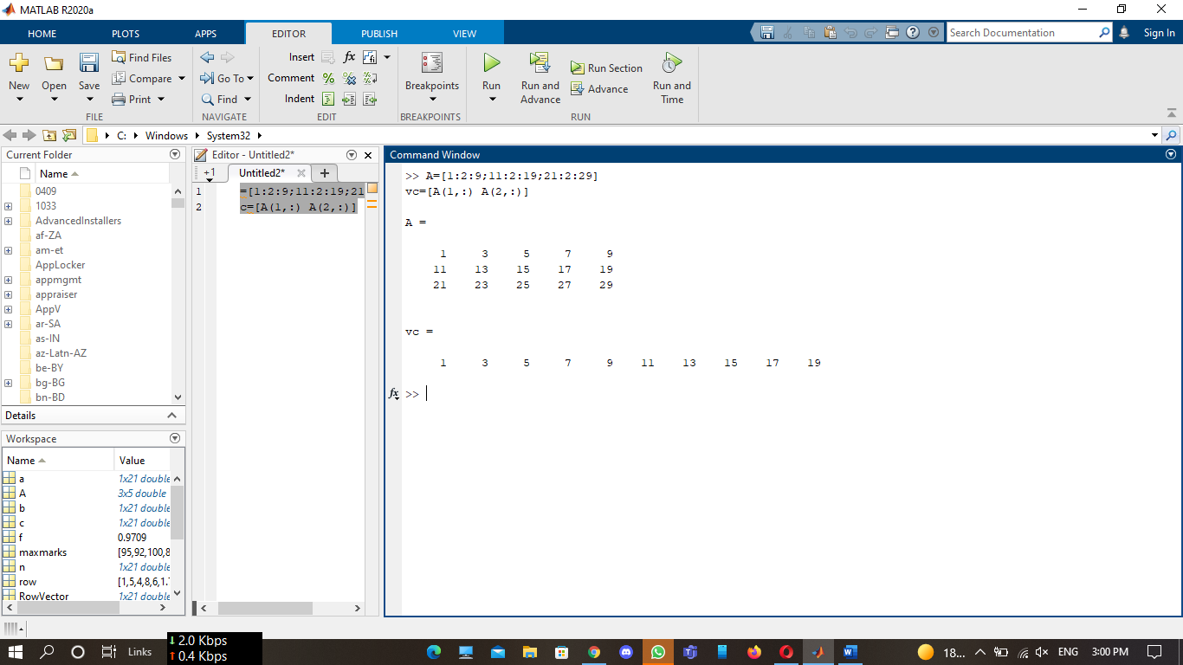

1. Create a six-element row vector named vd that contains the elements of the second and fifth columns of *A.*

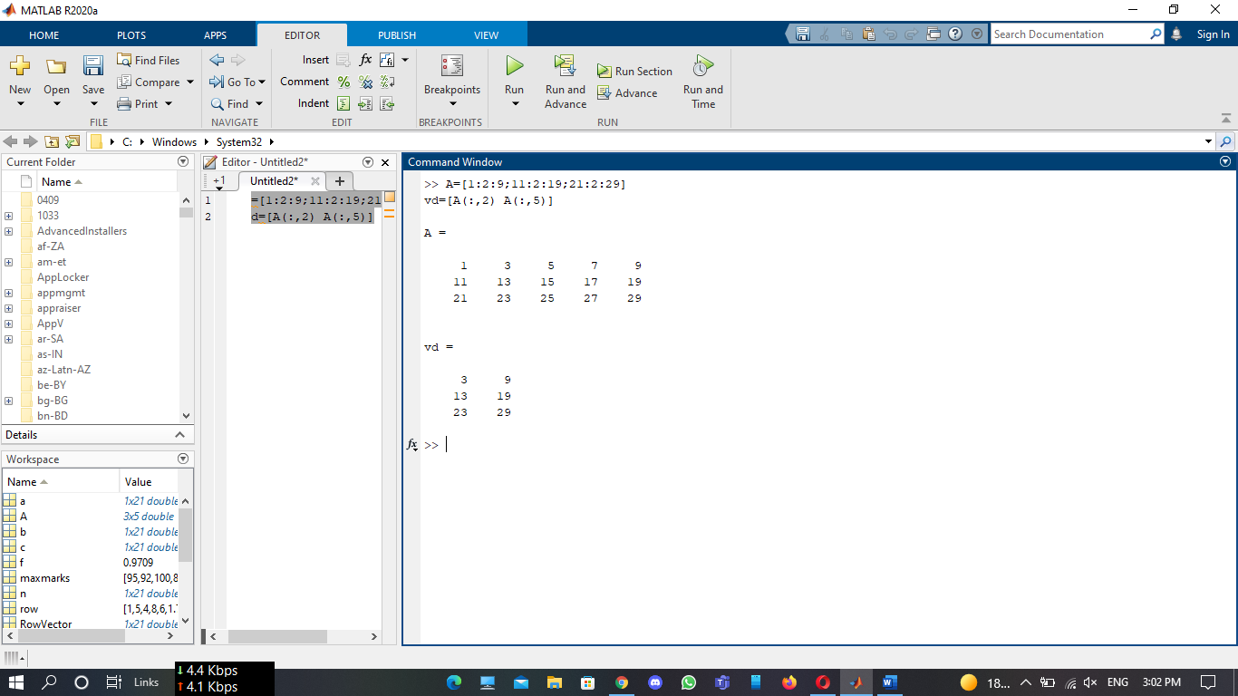

**Assignment 8:**

Solve the following problems in MATLAB Command Window.

1. Make two separate plots of the function one plot for –

4≤x≤4, and one for -2.7≤x≤2.7.

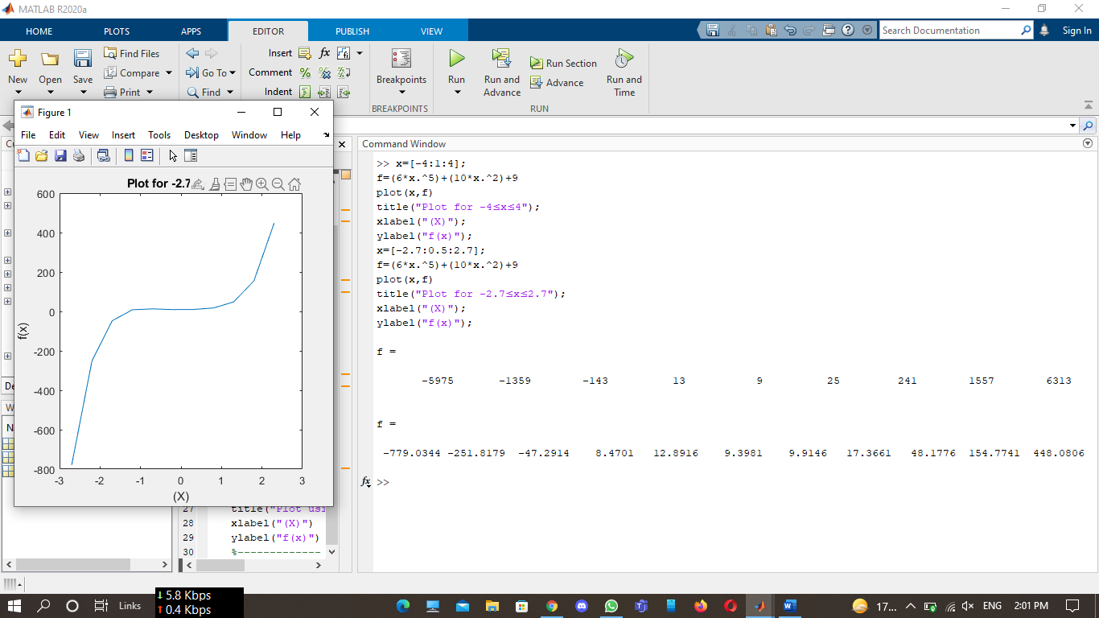

**2)** Plot the function for -10 ≤ x ≤ 10

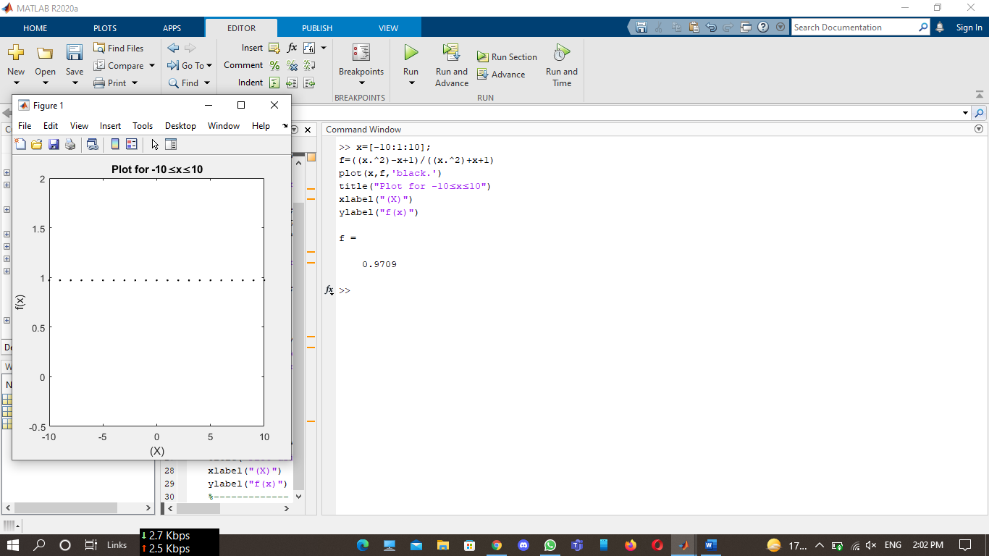

**3)** Use the fplot command to plot the function:

In the domain -4 ≤ x ≤ 6

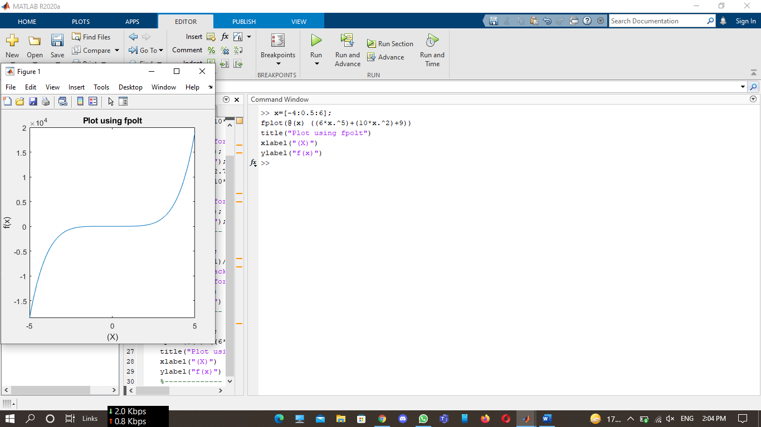

**Assignment 9:**

Plot the following data in MATLAB

|  |  |  |  |  |  |  |
| --- | --- | --- | --- | --- | --- | --- |
| **Year** | **2000** | **2001** | **2002** | **2003** | **2004** | **2005** |
| **Minimum Marks** | 23 | 25 | 20 | 30 | 28 | 35 |
| **Maximum Marks** | 95 | 92 | 100 | 85 | 90 | 93 |

***a)*** Label x Axis as year and y axis as marks

***b)*** The color of the Minimum marks graph should be green and maximum marks graph should be red.

***c)*** The range of x Axis should be 2000 to 2005 and y axis 20 to 100

***d)*** The title of the graph should be “six years marks record”.

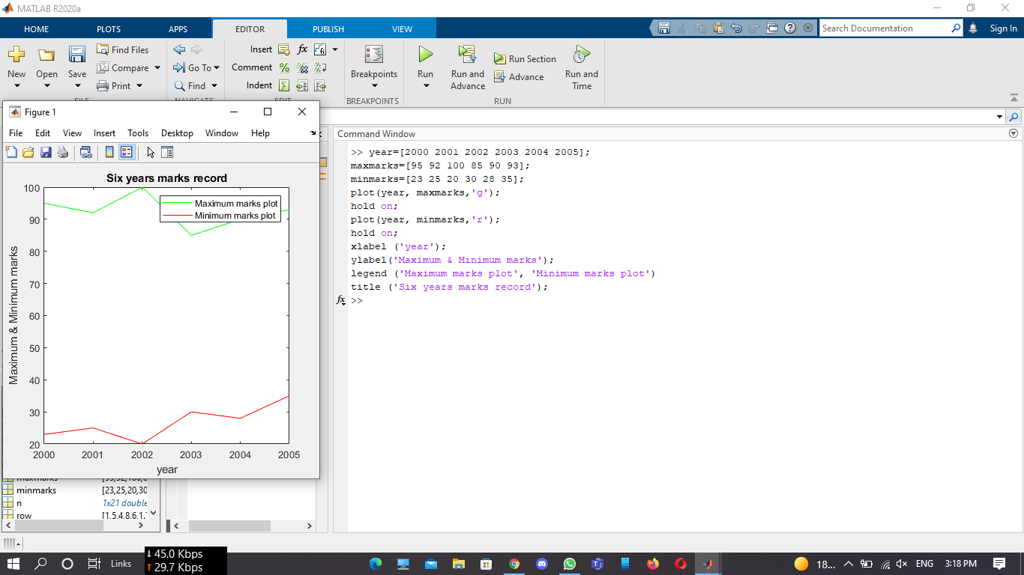

**Assignment 10:**

Generate and plot the following sequence





**



